NC Fiscal Year Admin Packet

Office of the City Clerk

Neighborhood Council Funding Program Fiscal Year Administrative Packet


Neighborhood Council:
Fiscal Year:
Downtown LA Neighborhood Council

2025-2026

NEIGHBORHOOD COUNCIL FUNDING PROGRAM FISCAL YEAR ADMINISTRATIVE PACKET

Summary
The Administrative Packet provides for a more comprehensive and complete record of all items that support the Neighborhood Councils’ (NC) fiscal and administrative operations, including its annual budget, Financial Officers, and any commitments for NC office space, storage facility,
P.O. Boxes, etc.

Goal(s)
The goal(s) of the Administrative Packet is to make it easier for NCs to identify, plan, and confirm, via a board vote, all fiscal and administrative requirements upfront each year so that our Office can prepare for and process funding requests and resulting contracts judiciously and expeditiously.

The Packet contains the following items:
- NC Funding Program Acknowledgements & Agreements – Signed by all Financial Officers

If a new Financial Officer is being appointed for the new Fiscal Year, please check the appropriate box for the Financial Officer(s).
- Completed Annual Budget
- Information pertaining to office space, meeting space, storage facility, Post Office Box (P.O. Box), and website services, as applicable.

Procedure
On a yearly basis, we require each NC to discuss, prepare, and approve the Administrative Packet. Once the NC board has voted on the Packet, the Packet and the completed Board Action Certification (BAC) Form are to be submitted to the NC Funding Program.
Your NC Treasurer can submit both documents, the Packet and BAC, by uploading them in the NC Funding System portal, Budget Allocation section, immediately after Board approval. Once received, reviewed, and accepted by our Program, your NC will gain full access to its funds. The NC Funding System portal website is https://cityclerk.lacity.org/NCFundPortal/#/login
As our Program awaits your Packet submission, access to your NC funds will be limited to $333.00 per month, until the annual budget, Administrative Packet, and BAC have been received and accepted. This limited amount is intended to assist your NC operationally for expenses related to conducting your NC meetings, i.e. meeting facility use fees, printing and photocopying of meeting documents, meeting refreshments/snacks, professional staff services.
If you have questions or require any assistance regarding the packet, please feel free to email us at clerk.ncfunding@lacity.org or call us at 213-978-1058.

NEIGHBORHOOD COUNCIL FUNDING PROGRAM
FINANCIAL OFFICERS LETTER OF ACKNOWLEDGEMENT & AGREEMENT
We, the undersigned, do hereby declare that as a result of an official action of the Governing Body of the Neighborhood Council (NC) named below:
- we are authorized to request City funding to support NC general operations,
- all items or services described or included in any related funding requests are exclusively intended to further the goals and objectives of the Neighborhood Council, and
- all reasonable precautions shall be exercised by the undersigned to fully safeguard, control and account for all use of funds. Proper accountability of all City funds is critical to the success of the NC Funding Program.
Therefore, by the signature(s) below, and on behalf of the Neighborhood Council named below, WE HEREBY AGREE to the terms and conditions as set forth in this Letter of Acknowledgement and all related documents as provided by the City, agree to expend funds in accordance with any applicable City rules, policies or procedures, and specifically agree to expend monies received by the Office of the City Clerk solely for public purposes relating to the goals and purposes of the Neighborhood Council named below, consistent with the scope and authority under the City Charter, the Plan for a Citywide System of Neighborhood Councils and any implementing ordinances. We have attended and participated in the City-provided training relating to the NC Funding Program.
WE FURTHER ACKNOWLEDGE and WE AGREE to comply with any requirements regarding use of the NC funds. WE AGREE to provide NC financial reports and/or supporting documentation to the Office of the City Clerk, Neighborhood Council Funding Program as requested and at monthly meetings to the Governing Body and stakeholders of the NC named below. WE AGREE that the Office of the City Clerk and other City representatives may make on-site visits to inspect and review all NC financial records, upon providing reasonable advance notice to the NC Treasurer or designated representatives.

WE ACKNOWLEDGE THAT A NEW LETTER OF ACKNOWLEDGEMENT MUST BE FILED IF THERE IS ANY CHANGE OF FINANCIAL OFFICERS.

Neighborhood Council Financial Officers - Names and Signatures:

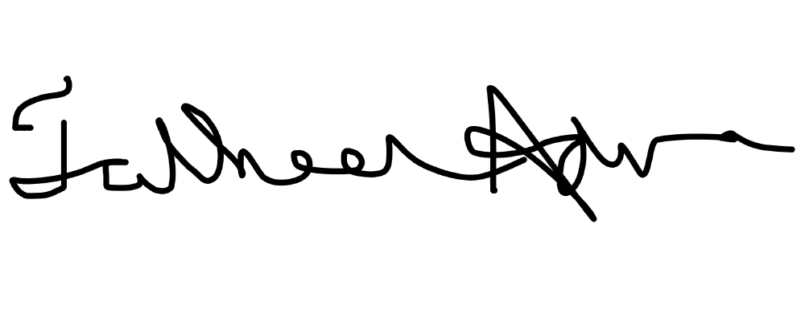
Treasurer □✔Please check here if a new Treasurer is being appointed

October 14, 2025

SIGNATURE OF THE TREASURER DATE
Tatheer Adnan tatheer.adnan@dlanc.com
PRINT NAME OF THE TREASURER EMAIL
Area-Wide Social Service Provider 347-977-9492
BOARD POSITION PHONE NUMBER

CONTINUES OTHER SIDE

2nd Signer □✔Please check here if a new 2nd Signer is being appointed

October 09, 2025

SIGNATURE OF THE 2nd SIGNER DATE
Jens Midthun jens.midthun@dlanc.com
PRINT NAME OF THE 2ND SIGNER EMAIL
President 1-952-270-2017
BOARD POSITION PHONE NUMBER
Alternate Signer □✔Please check here if a new Alt. Signer is being appointed

October 8, 2025
(If not applicable, please indicate “N/A”)
SIGNATURE OF THE ALTERNATE SIGNER
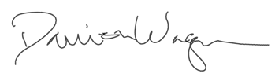
DATE
Damion Wagner damion.wagner@dlanc.com
PRINT NAME OF THE ALTERNATE SIGNER EMAIL

Area-Wide Social Service Provider Director 3233636116
BOARD POSITION PHONE NUMBER

1st Bank Cardholder □✔Please check here if a new Cardholder is being appointed

October 09,2025
SIGNATURE OF THE 1st BANK CARD HOLDER DATE
Tatheer Adnan tatheer.adnan@dlanc.com
PRINT NAME OF THE 1st BANK CARD HOLDER EMAIL

Area-Wide Social Service Provider Director
347-977-9492

BOARD POSITION PHONE NUMBER
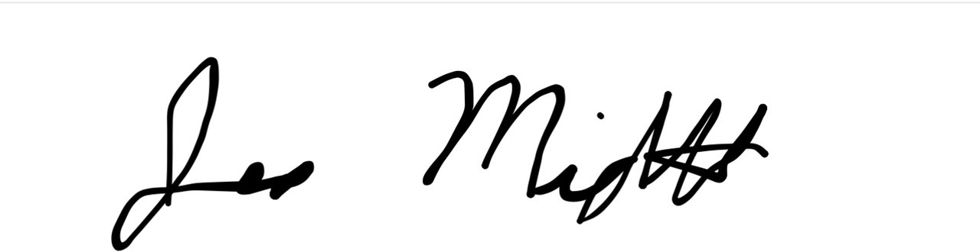
2nd Bank Cardholder □✔Please check here if a new Cardholder is being appointed

October 09, 2025
SIGNATURE OF THE 2nd BANK CARD HOLDER DATE
Jens Midthun jens.midthun@dlanc.com
PRINT NAME OF THE 2nd BANK CARD HOLDER EMAIL

President 9522702017

BOARD POSITION PHONE NUMBER

*** Bank Cardholders, please read further next page ***

NEIGHBORHOOD COUNCIL FUNDING PROGRAM
BANK CARDHOLDER ACKNOWLEDGEMENT & AGREEMENT OF RESPONSIBILITIES
This document outlines the responsibilities that I, as the Neighborhood Council Bank Cardholder, have as the primary custodial holder of a City Los Angeles Neighborhood Council (NC) Bank Card, referred herein as "the card" for the Neighborhood Council named below. My signature indicates that I have read and understand these responsibilities and further, that I agree to adhere to the guidelines established by the Office of the City Clerk and approved by the City Controller for the use of City funding as it relates to the Neighborhood Council Funding Program.

- I understand that the City of Los Angeles Neighborhood Council Card is intended to facilitate the purchase and payment of materials or services required for the conduct of official Neighborhood Council business only.
- I agree to make only those purchases consistent with the type of purchases authorized by the Office of the City Clerk and approved by the NC Governing Board.
- I understand that under no circumstances will I use the Card to make personal purchases either for myself or for others. The Card is issued in the name of the Neighborhood Council and I serve as the Card custodian. I agree that should I willfully violate the terms of this Agreement and use of the Card for personal use or gain that I will reimburse the City of Los Angeles for all incurred charges and any fees related to the collection of those charges.
- Uses of the Card not authorized by the Office of the City Clerk can be considered misappropriation of City funds. This could result in (a) immediate and irrevocable forfeiture of the Card, and /or (b) potential de- certification action. I understand that the Card must be surrendered upon termination of any official position with the Neighborhood Council to which the card is issued. I agree to maintain the Card with appropriate security whenever and wherever I or any other authorized person may use the Card. If the Card is stolen or lost, Iagree to immediately notify the Office of the City Clerk.
- Iunderstand that since the Card is the property of the Bank and authorized for issue by the City of Los Angeles, Iam required to comply with internal control procedures designed to protect City assets. This may include being asked to produce the Card, receipts, and/or statements to validate its existence and to audit its use.

- I understand that I will have access to the Funding Program System portal via the Internet where all card transactions will be posted by the Bank when the card is used. I understand that I am required to obtain itemized receipts for all card transactions and upload the itemized receipts to the Funding Program System portal to verify the posted card transaction. Uploading the required itemized receipt is necessary for my NC Monthly Expenditure Report (MER) to be generated by the Funding Program System portal. The MER must be reviewed and approved by the NC Governing Board before being sub mitted to the Office of the City Clerk as a complete Report.
- I understand that all transactions on the Card will reduce the funds available to the NC. I understand that the Bank will not accept any limit increases from me.
- I understand that the Card is solely provided to the designated NC cardholder and that assignment of the Card is based on the understanding that I need to purchase materials required for the conduct of Neighborhood Council business. I understand that custodial possession of the Card is not an entitlement nor reflective of title or position.

- As a Neighborhood Council Financial Officer, I have signed and received a copy of both the NC Funding Program Bank Cardholder Agreement of Responsibilities and Financial Officers Letter of Acknowledgement, have attended and completed the required NC Funding Program training, and understand the requirements and limitations regarding the NC Bank Card's use.

PLEASE SIGN NEXT PAGE

Tatheer Adnan
1st Bank Cardholder
SIGNATURE OF THE 1st BANK CARD HOLDER
PRINT NAME OF THE 1st BANK CARD HOLDER

2nd Bank Cardholder

October 09, 2025

DATE

October 9, 2025

SIGNATURE OF THE 2nd BANK CARD HOLDER DATE

Jen Midthun
PRINT NAME OF THE 2nd BANK CARD HOLDER

NEIGHBORHOOD COUNCIL FUNDING PROGRAM ANNUAL BUDGET TEMPLATE – FISCAL YEAR 2020-2021
The annual budget is a plan for the utilization of the NC’s financial resources. It should be used as a strategic financial road map to conduct activities and efforts that will help the NC achieve its mission, goals, and objectives. The budget should include the input of stakeholders, be accessible, and comply with the rules that govern the use of NC public funds.

As a planning tool, the annual budget allows the NC board to allocate its funds, both regular annual funds and rollover funds, if any, into the following Expenditure Categories:
  - General and Operational Expenditures

Office/Operational
    - Outreach
    - Elections
  - Neighborhood Purposes Grants (NPGs)
  - Community Improvement Projects (CIPs)

With the exception of certain expenditures related to Office/Operational items, the annual budget cannot be used as authorization or approval of actual payments to vendors. All payments related to Outreach purchases, activities, and events, Elections, NPGs, and CIPs must be considered and approved through separate board motions, not as part of the board approval of the annual budget.

The annual budget may be accepted as authorization for payment for certain monthly and recurring Office/Operational expenditures only, such as those listed below, when itemized in the Office/Operational Expenditure Category. Please see the sample itemized Office/Operational budget allocations next page.
- Office lease payments
- Office supplies and equipment expenses, not including inventory items
- Storage facility lease payments
- P.O. Box payments
- Office telephone and Internet services
- Refreshments/snacks for board/committee meetings
- Website hosting and maintenance services
- Professional meeting/office-related services, i.e. translators, minute-takers, audio services
- Printing and copying for meetings/office-related purposes only
- Printing NC business cards

The annual budget template form provided here is an optional tool. Your Neighborhood Council may submit its annual budget on a form different from this template as long as it only contains the same budget allocation Expenditures Categories listed above.

For more details on the Administrative Packet, Fiscal Year annual budget, and rollover of funds unspent at the end of the Fiscal Year, please review the Policies and Guidelines, Policy 1.1, found on our website: https://clerk.lacity.org/clerk-services/nc-funding

Sample Itemized Budget Allocations for Office/Operational Expenditures




Office/Operational Expenditures Category

Office Rent ($500/month x 12 months)
Office Supplies (paper, ink, staples, pens, binders, business cards, etc.)
Printer/Copy Machine Lease Internet Service (Spectrum) Telephone Service (Ooma) Website Hosting and Maintenance
Printing and Photocopying for Meetings
Meeting Facility Fees (Riverside Elementary School) Minute-Taker for Meetings (AppleOne) Refreshments/Snacks for Meetings
$6,000.00
$500.00
$1,500.00
$1,000.00
$500.00
$1,500.00
$300.00
$1,500.00
$1,500.00
$1,200.00

Total Office/Operational Expenditures $15,500.00

Neighborhood Council Annual Budget for Fiscal Year: 2025-2026
Annual Budget Funds | $ 25,000.00
Rollover Funds* | $ 11,797.65
Total Annual Budget Funds | $ 36,797.76

Office/Operational Expenditures Category
Google Workspace | $5000.00
Extra Space Storage | $3000.00
DocHub | $200.00
Web Hosting | $200.00
Domain Registration- Network Solutions | $ 250.00
LAPD Security Services | $ 3000.00
Web Maintenance | $ 400.00
Translation/Notetaker | $1,600.00
Meeting Space | $2750.00
Total Office/Operational Expenditures | $16,400
*The Funding Program will notify each NC of their Fiscal Year closing balance including available rollover funds and/or applicable adjustment, if any, approximately August 1st or next business day. Depending on when an NC submits its Admin Packet/annual budget, the NC may need to revise and resubmit its annual budget to account for any rollover and/or adjustments.

Outreach Expenditures Category
Business Cards and Badges | $1000.00
Advertising | $3000.00
Tabling/Events | $3,000.00
Event Sponsorships | $2,000.00
Promotional Items | $2000.00
Constituent e-Newsletter Service | $1200.00
Total Outreach Expenditures | $ 12,200

Election Expenditures Category
Campaign Operations & Supplies | 300.20
Total Election Expenditures | $300.20

Neighborhood Purposes Grants (NPG) Expenditures Category
Total NPG Expenditures | $ 2726.30

Community Improvement Projects (CIP) Expenditures Category
Total CIP Expenditures | $5171.26

TOTAL ANNUAL BUDGET ALLOCATIONS
Office/Operational Expenditures | $16,400
Outreach Expenditures | $12,200
Election Expenditures | $300.20
General and Operational Expenditures | 28,900.20
Neighborhood Purposes Grants (NPG) Expenditures | $ 2726.30
Community Improvement Projects (CIP) Expenditures | $5171.26
TOTAL EXPENDITURES FOR THE FISCAL YEAR | $ 36,797.76

P.O. Box:
□ Existing(may need to renew agreement) □ New(new agreement may be needed) □ Donated □✔NA
Property Name/Owner:
NC P.O. Box Address
Property Owner Address:
Property Owner Phone Number:
Property Owner Email:
Name on P.O. Box Account:

Website Services:
□✔ Existing(may need to renew agreement) □ New(new agreement may be needed) □ Donated □ NA
Name of Website Services Provider:
Service Provider Address:
Service Provider Phone Number:
Service Provider Email:
Type of Services Provided:

When the Board completes and approves the Admin Packet, the NC Treasurer may submit the Packet and BAC Form online in the NC Funding System portal, Budget Allocation section. The NC Funding System portal website is https://cityclerk.lacity.org/NCFundPortal/#/login

Please contact our Office for any questions you may have. We are here to help.
Clerk.NCFunding@lacity.org (213)978-1058

C Fiscal Year Admini trative Packet Page 11 of ll

EIGHBORl-100D CO IL FU DI G PROGRAM L ASES & AGREEMENTS
Please con1plete the ii 11owing information.. a applicable.. for any leas or rvice agreen1ents our currently ha· r plan on ccuring in the Fi cal Year in ol ing ffice pace. m ting space.
torage facilities.. P.O. Boxe . and/or website er ice . If cctions belo\ do not appl., to your
please Ject A on the ection that do not apply. If you have n1ore than nc Meeting Locati n then plea e pro ide the same information on an additional page. The information pro ided on thi form i to c nfirm servic that an ma • currently ha or that it \\·ould like to ecure in the
i. cal Year which may require a Cit agrcem nt. If an agre 1nent need to be drafted from the information pro idcd, the board will be notified and ad i cd to agendizc and appr v t.h drafted agrcen1ent at a future board n1 eting· The approval th dmini trati c Pack t/annual budget does not replace the ote the board will need to tak to appro\e an agreement needed.
Office Location:
0 Exisling(ma., need to renew agreement) □ e\\(ncw agreement may be needed) D Donated l!f NA
Property ame:
Property Addres :
Property Q\vner ame:
Property , ncr Phone Tumbcr:
Property Owner 1nai l:
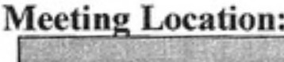
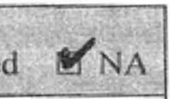
□ Existing(may need to renew agreemcnl)
D
e\\ (new agreement ma_ be needed) D Donate
Property O\.vncr Cmail:
Property O, ner Phone umber:
Property O" ner ame:
Property ddrc
Property ainc:
toraae Facility:
!If Existing(may need to renew agreement) D ·ew(new agreement may be needed) 0 Donated □ A Facility ame/O\vner Extra Space Storage ( Unit B1235)
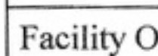  Facility Addr s:  vvner Phone umber: | 1000 N Main St, Los Angeles CA  7 -Z.... > 6, (( � | 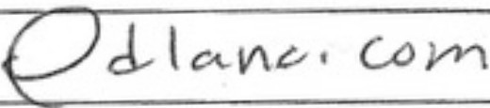
Facility Owner ..,maiI: | d V'-AI 6 '--' 1; wa lA.0
ame on Facilit ccount: | Damion Wagner

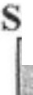
OfFlCL:. OF Tl reCl I Y Cl.ERK clcrk.ncfonding@lacity.c.lrgl t 3-()78-1058 0521

