Business & Innovation Committee

Payas Parab
CHAIR

Heera Kapoor
Paul Kaufman
Jeremy Masys
Damion Wagner
Lori Aliksanian
Andrew Wong
Jens Midthun (Ex-Officio)
CITY OF LOS ANGELES
CALIFORNIA

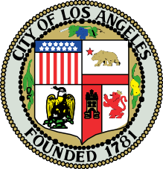
DRAFT
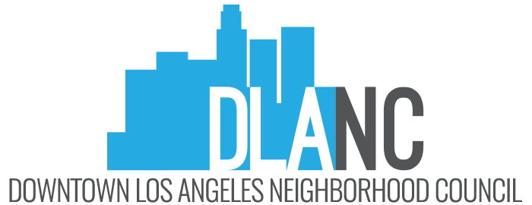

WWW.DLANC.COM

EMAIL: INFO@DLANC.COM

DOWNTOWN LOS ANGELES NEIGHBORHOOD COUNCIL

Ad Hoc Business and Innovation Committee

MEETING AGENDA

Los Angeles Central Library,
Meeting Room B 630 W 5th Street, Los Angeles, CA 90071
Tuesday, February 24, 2026 - 6:00 PM

Contact: payas.parab@dlanc.com for more information. You can also reach the entire committee via bic@dlanc.com

Si requiere servicios de traducción, favor de avisar al Concejo Vecinal 3 días de trabajo (72 horas) antes del evento. Por favor contacte (Secretary Contact Phone Number), Payas Parab, al (+1 475-329-0079) o por correo electrónico payas.parab@dlanc.com para avisar al Concejo Vecinal. Comments from the public on other matters not appearing on the agenda that are within the Board’s jurisdiction will be heard during the General Public Comment period. Please note that under the Brown Act, the Board is prevented from acting on a matter that you bring to its attention during the General Public Comment period; however, the issue raised by a member of the public may become the subject of a future Board meeting. Public comment is limited to 2 minutes per speaker, unless adjusted by the presiding officer of the Board.

Instructions on how to sign up for public comment will be given to listeners at the start of the meeting.

1. Call to Order / Roll Call 6:07pm
Present (P), Absent (A),
Payas Parab (Chair) | P | Paul Kaufman | P
Damion Wagner | P | Andrew Wong | P
Heera Kapoor | P | Jeremy Masys | P
Lori Aliksanian | P | Jens Midthun (Ex-Officio/Non-Voting) | P

2. General Public Comment on Non-Agenda Items:
Comments from the public on agenda items will be heard only when the respective item is being considered. Comments from the public on other matters not appearing on the agenda that are within the Board’s jurisdiction will be heard during the General Public Comment period. Please note that under the Brown Act, the Committee is prevented from acting on a matter that you bring to its attention during the General Public Comment period; however, the issue raised by a member of the public may become the subject of a future Committee meeting. Public comments are limited to two minutes per speaker with a total time of ten minutes. (The chair, depending on the number of speakers and time considerations, may change these parameters.) (20 min. cap).
3. Approval of minutes for 2/3 meeting
4. New Business (All items for discussion and possible action)
a. Discussion: Possibilities and community action around a vacancy tax
The committee discussed a vacancy tax on commercial spaces that stay empty for over 365 days; starts at $250 per linear foot. Tax rises to $500 per linear foot after a second year of vacancy to incentivize leasing.
b. Discussion: Outline drafting/brainstorming Small Business Resource guide
i. Outline of content (start-up resources, city contacts,
permitting
resources, financing, etc)
ii. Compilation and review of existing content known by community
members
c. Discuss technology & tools that can help DLANC
d. Local’s pass
i. Discuss possible “locals pass” that allows locals premium access
to local bars and restaurants
e. Possible discussion on business-related topics in DLANC Charter Reform Comment Letter
General Public Comment on Non-Agenda Items:
Comments from the public on agenda items will be heard only when the respective item is being considered. Comments from the public on other matters not appearing on the agenda that are within the Board’s jurisdiction will be heard during the General Public Comment period. Please note that under the Brown Act, the Committee is
prevented from acting on a matter that you bring to its attention during the General Public Comment period; however, the issue raised by a member of the public may become the subject of a future Committee meeting. Public comments are limited to two minutes per speaker with a total time of ten minutes. (The chair, depending on the number of speakers and time considerations, may change these parameters.) (20 min. cap).
5. Other Committee Comments and Announcements -
6. Next Meeting: 3/31/2026
7. Adjournment
PUBLIC INPUT AT NEIGHBORHOOD COUNCIL MEETINGS: Comments from the public on agenda items will be heard only when the respective item is being considered. Comments from the public on other matters not appearing on the agenda that are within the committee’s jurisdiction will be heard during the General Public Comment period. Please note that under the Brown Act, the committee is prevented from acting on a matter that you bring to its attention during the General Public Comment period; however, the issue raised by a member of the public may become the subject of a future committee meeting. Public comment is limited to 2 minutes per speaker, unless adjusted by the presiding officer.
CONSENT ITEMS: There will be no separate discussion of Consent items as they are considered routine and will be adopted by one motion. If a member of the Board, Committee, or a stakeholder requests discussion on a particular item, that item will be removed from Consent and considered separately. Such items will be moved to the end of the agenda.
NOTICE TO PAID REPRESENTATIVES: If you are compensated to monitor, attend, or speak at this meeting, City law may require you to register as a lobbyist and report your activity. See Los Angeles Municipal Code §§ 48.01 et seq. More information is available at ethics@lacity.org/lobbying. For assistance, please contact the Ethics Commission at (213) 978-1960 or ethics.commission@lacity.org.
PUBLIC ACCESS OF RECORDS: In compliance with Government Code section 54957.5, non-exempt writings that are distributed to a majority or all of the board members in advance of a meeting may be viewed on our website by clicking on the following link: www.dlanc.com, or at the scheduled meeting. In addition, if you would like a copy of any record related to an item on the agenda, please contact the secretary, terin.ngo@dlanc.com
POSTING: In compliance with Government Code section 54954.2(a), Neighborhood Council agendas are posted for public review at Department of Recreation & Parks - Pershing Square Office, 532 S. Olive and at www.dlanc.com. You can also receive our agendas via email by subscribing to L.A. City’s Early Notification System at:
https://www.lacity.org/government/subscribe-agendasnotifications/neighborhood-councils.
RECONSIDERATION AND GRIEVANCE PROCESS: For information on the DLANC’s process for board action reconsideration, stakeholder grievance policy, or any other procedural matters related to this Council, please consult the DLANC Bylaws. The Bylaws are available at our Board meetings and our website www.dlanc.com.
DISABILITY POLICY: The Downtown Los Angeles Neighborhood Council complies with Title II of the Americans with Disabilities Act and does not discriminate on the basis of any disability. Upon request, the Downtown Los Angeles Neighborhood Council will provide reasonable accommodations to ensure equal access to its programs, services, and activities. Sign language interpreters, assistive listening devices, or other auxiliary aids and/or services may be provided upon request. To ensure availability of
services, please make your request at least 3 business days prior to the meeting you wish to attend by contacting the Department of Neighborhood Empowerment at (213) 978-1551 or email NCSupport@lacity.org.
STATE OF CALIFORNIA PENAL CODE SECTION 403 (Amended by Stats, 1994, Ch. 923, Sec. 159. Effective January 1, 1995.) Every person who, without authority of law willfully disturbs or breaks up any assembly or meeting that is not unlawful in its character, other than an assembly or meeting referred to in Section 302 of the Penal Code or Section 18340 of the Elections Code, is guilty of a misdemeanor.

