CITY OF LOS ANGELES
PLANNING & LAND USE COMMITTEE  SAMIR BITAR  CHAIR  PATTI BERMAN  AUDREY VON AHRENS  TONJA BOYKIN  TYLER MURPHY  REEYAN RAYNES  JOHN SWARTZ  CHRISTIAN DITTMER  MICHAEL ROBLETO  ALLEN GROSS  JUSTIN WEISS | CALIFORNIA | 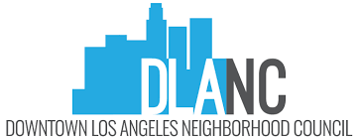  WWW.DLANC.COM  EMAIL: DLANC@EMPOWERLA.ORG
 | 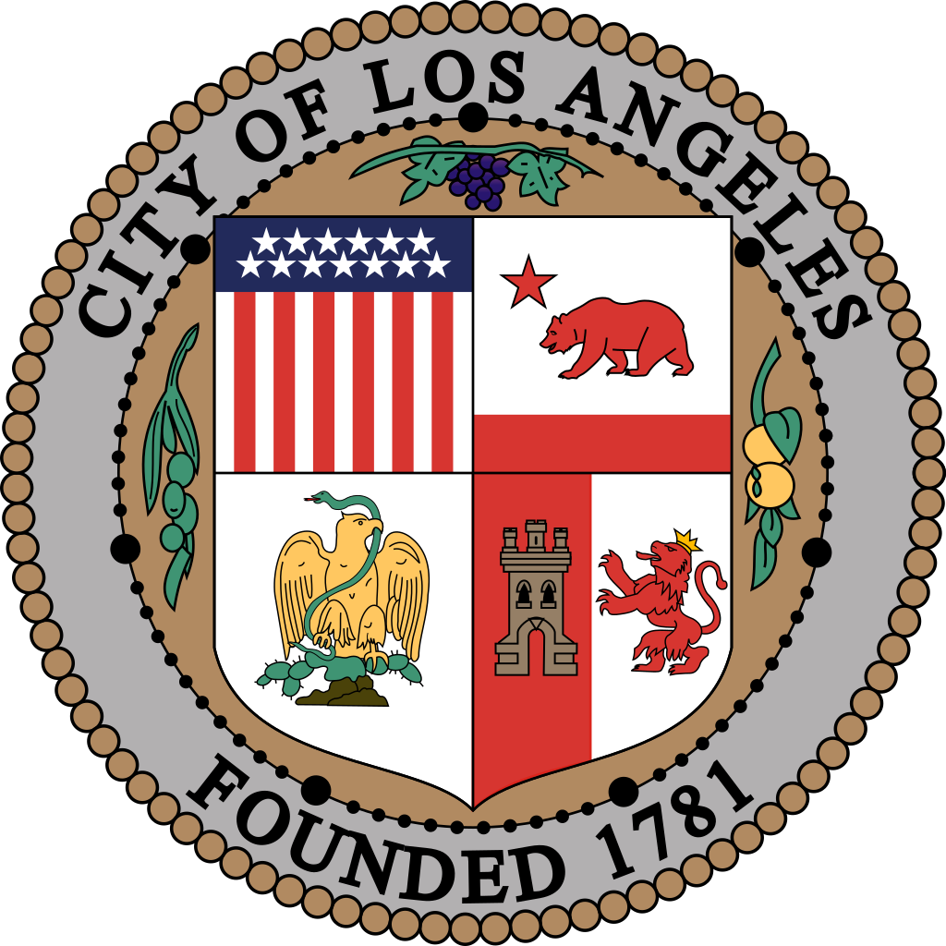

DOWNTOWN LOS ANGELES NEIGHBORHOOD COUNCIL
PLANNING & LAND USE COMMITTEE
REGULAR MEETING AGENDA

TBA
Tuesday, January 16, 2024 - 6:30 PM

Contact: Samir.bitar@dlanc.com for more information

Si requiere servicios de traducción, favor de avisar al Concejo Vecinal 3 días de trabajo (72 horas) antes del evento. Por favor contacte Secretaria Debby Zhou por correo electrónico debby.zhou@dlanc.com para avisar al Concejo Vecinal.

Comments from the public on other matters not appearing on the agenda that are within the Board’s jurisdiction will be heard during the General Public Comment period. Please note that under the Brown Act, the Board is prevented from acting on a matter that you bring to its attention during the General Public Comment period; however, the issue raised by a member of the public may become the subject of a future Board meeting. Public comment is limited to 2 minutes per speaker unless adjusted by the presiding officer of the Board.

Instructions on how to sign up for public comment will be given to listeners at the start of the meeting.

CALL TO ORDER AND COMMITTEE ROLL CALL
Samir Bitar – Chair
Patti Berman
Tyler Murphy
Christian Dittmer
Michael Robleto
Reeyan Raynes
John Swartz
Justin Weiss
Tonja Boykin
Audrey von Ahrens
Justin Weiss

- Committee Member Introductions
- Approve Minutes from 10/2023
- Report on last DLANC Board Meeting concerning items presented by PLUC.
- Declarations of Ex Parte communications

- GENERAL PUBLIC COMMENT - Comments from the public on non-agenda items within the Committee’s subject matter jurisdiction. Comments from the public on agenda items will be heard only when the respective item is being considered. Comments from the public on other matters not appearing on the agenda that are within the Committee’s jurisdiction will be heard during the General Public Comment period. Please note that under the Brown Act, the Committee is prevented from acting on a matter that you bring to its attention during the General Public Comment period: however, the issue raised by a member of the public may become the subject of a future Committee meeting. Public comments are limited to two minutes per speaker with a total time of ten minutes. (The chair, depending on number of speakers and time considerations, may change these parameters.)

- COMMITTEE MEMBER COMMENTS - Committee members are asked to keep their comments brief and relevant to the topic or project being discussed. Committee member comments will be limited to two minutes and all committee members will be given the opportunity to make a comment before additional comments are provided by committee members.

- OLD BUSINESS – None

- NEW BUSINESS

  - Presentation by: Steve Rawlings

Case Number: ZA-2023-4215-CUB

Project Location: 735 S Figueroa St, Ste 207-307

Project Description: A Plan Approval to continue to allow the sale of a full-line of alcoholic beverages for on-site consumption (ABC Type 47 License) at an existing 8,304 sq ft restaurant with 254 indoor seats and 34 outdoor seats on a 584 sq ft patio and hours of operation from 11 am to 11 pm daily in a C2-4D zone.

Project Requests: Plan Approval to continue to allow the sale of a full-line of alcoholic beverages both indoors and on the patio of an existing restaurant.

Recommended action: To be Determined.

  - Presentation by: Brett Engstrom

Case Number: ZA-2013-1182-CUB-PA1

Project Location: 1111 Wilshire Blvd., Los Angeles, CA 90017

Project Description: Plan Approval to allow the continued sale of a full line of alcohol for on-site consumption in conjunction with an existing restaurant.

Project Requests: Plan Approval (PA) to renew a previous CUB grant

Recommended action: To be Determined.

- GENERAL PUBLIC COMMENT - Comments from the public on non-agenda items within the Committee’s subject matter jurisdiction. Comments from the public on agenda items will be heard only when the respective item is being considered. Comments from the public on other matters not appearing on the agenda that are within the Committee’s jurisdiction will be heard during the General Public Comment period. Please note that under the Brown Act, the Committee is prevented from acting on a matter that you bring to its attention during the General Public Comment period: however, the issue raised by a member of the public may become the subject of a future Committee meeting. Public comments are limited to two minutes per speaker with a total time of ten minutes. (The chair, depending on number of speakers and time considerations, may change these parameters.)

- Committee Member Comments and Announcements
- Proposed delivery dates – Motions, Letters and Minutes 2/2/2024.
- Next Meeting(s): February 20, 2024
- Adjournment

PUBLIC INPUT AT NEIGHBORHOOD COUNCIL MEETINGS: The public is requested to fill out a “Speaker Card” to address the [committee] on any agenda item before the committee takes an action on an item. Comments from the public on agenda items will be heard only when the respective item is being considered. Comments from the public on other matters not appearing on the agenda that are within the committee’s jurisdiction will be heard during the General Public Comment period. Please note that under the Brown Act, the committee is prevented from acting on a matter that you bring to its attention during the General Public Comment period; however, the issue raised by a member of the public may become the subject of a future committee meeting. Public comment is limited to 2 minutes per speaker, unless adjusted by the presiding officer.

CONSENT ITEMS: There will be no separate discussion of Consent items as they are considered routine and will be adopted by one motion. If a member of the Board, Committee, or a stakeholder requests discussion on a particular item, that item will be removed from Consent and considered separately. Such items will be moved to the end of the agenda.

NOTICE TO PAID REPRESENTATIVES: If you are compensated to monitor, attend, or speak at this meeting, City law may require you to register as a lobbyist and report your activity. See Los Angeles Municipal Code §§ 48.01 et seq. More information is available at ethics@lacity.org/lobbying. For assistance, please contact the Ethics Commission at (213) 978-1960 or ethics.commission@lacity.org.

PUBLIC ACCESS OF RECORDS: In compliance with Government Code section 54957.5, non-exempt writings that are distributed to a majority or all of the board members in advance of a meeting may be viewed on our website by clicking on the following link: www.dlanc.com, or at the scheduled meeting. In addition, if you would like a copy of any record related to an item on the agenda, please contact the secretary, debby.zhou@dlanc.com.

POSTING: In compliance with Government Code section 54954.2(a), Neighborhood Council agendas are posted for public review at Department of Recreation & Parks - Pershing Square Office, 532 S. Olive and at www.dlanc.com. You can also receive our agendas via email by subscribing to L.A. City’s Early Notification System at:
https://www.lacity.org/government/subscribe-agendasnotifications/neighborhood-councils.

RECONSIDERATION AND GRIEVANCE PROCESS: For information on the DLANC’s process for board action reconsideration, stakeholder grievance policy, or any other procedural matters related to this Council, please consult the DLANC Bylaws. The Bylaws are available at our Board meetings and our website www.dlanc.com.

DISABILITY POLICY: The Downtown Los Angeles Neighborhood Council complies with Title II of the Americans with Disabilities Act and does not discriminate on the basis of any disability. Upon request, the Downtown Los Angeles Neighborhood Council will provide reasonable accommodations to ensure equal access to its programs, services, and activities. Sign language interpreters, assistive listening devices, or other auxiliary aids and/or services may be provided upon request. To ensure availability of services, please make your request at least 3 business days prior to the meeting you wish to attend by contacting the Department of Neighborhood Empowerment at (213) 978-1551 or email NCSupport@lacity.org.

STATE OF CALIFORNIA PENAL CODE SECTION 403 (Amended by Stats, 1994, Ch. 923, Sec. 159. Effective January 1, 1995.) –
Every person who, without authority of law willfully disturbs or breaks up any assembly or meeting that is not unlawful in its character, other than an assembly or meeting referred to in Section 302 of the Penal Code or Section 18340 of the Elections Code, is guilty of a misdemeanor.

SERVICIOS DE TRADUCCION: Si requiere servicios de traducción, favor de avisar al Concejo Vecinal 3 días de trabajo (72 horas) antes del evento. Por favor contacte NCSupport@lacity.org.

